
User Training
Project Manager

User Guide | 

CONTENTS
OVERVIEW ................................................................................................................................................................. 3
COMMON TEMPUS SHORTCUTS ..................................................................................................................................4
TEMPUS RESOURCE NAVIGATION ............................................................................................................................... 5
LOGGING IN ............................................................................................................................................................................................... 5 HOMEPAGE................................................................................................................................................................................................ 5 RECOMMENDED NOTIFICATION SUBSCRIPTIONS ........................................................................................................................................... 7
PROJECT MANAGEMENT GRID ....................................................................................................................................8
GRID OVERVIEW ......................................................................................................................................................................................... 8 VIEWING PROJECT ATTRIBUTES ................................................................................................................................................................... 9
SINGLE PROJECT ALLOCATION GRID ......................................................................................................................... 10
GRID OVERVIEW ....................................................................................................................................................................................... 10 CREATING RESOURCE REQUESTS ............................................................................................................................................................... 11 ADVANCED ASSIGNMENT OPTIONS............................................................................................................................................................ 13 VIEWING RESOURCE REQUEST STATUS ...................................................................................................................................................... 14
BULK PROJECT ALLOCATION FLATGRID .................................................................................................................... 15
GRID OVERVIEW ....................................................................................................................................................................................... 15 CREATING VIEWS USING A PUBLIC VIEW ..................................................................................................................................................... 17 ACTIONS IN THE BPAFLATGRID................................................................................................................................................................. 18 Update existing assignments ............................................................................................................................................................ 18 Add new assignments ....................................................................................................................................................................... 19 View Pending Resource Requests ...................................................................................................................................................... 20
Valkeen GmbH ∙ Bahnhofstrasse 64 ∙ 8001-Zürich, Switzerland
www.valkeen.com ∙ © 2025 Valkeen GmbH. All rights reserved.
CONFIDENTIALITY/EMAIL NOTICE: The material in this document contains confidential and privileged information intended only for the addressee. Do not distribute, copy, forward, or disclose the contents of this document without the express consent of Valkeen GmbH.
Page 2 of 20

User Guide | 

OVERVIEW
1.User Access:
Tempus access will vary based on the setup of each individual user (managed by your Admin team) Resources who require access can login via SSO and will be assigned a user role and security group
2.Resource Types:
There are two types of resources that can be setup in Tempus
oNamed resources: Individuals allocated to projects and/or setup as Tempus users
oDemand Planning resources: Unnamed resources; generic placeholders for a team or role, used solely for planning
3.Project Types:
There are three types of projects setup in your Tempus instance
a.Standard projects: “Interrelated tasks organized together in order to reach a specific outcome” b.Opportunities: Projects in the proposal phase, still pending approval.
c.Non-Project Activities projects: Absence, Admin, Run, Change, etc.
4.Assignments
Assignments are created by linking a Resource to a Project
a.Assignments must include a specific number of time units (Hours, FTE, Mandays, etc.) b.Assignments can be created for one project at a time, or for multiple projects at the same time c.Assignments can be applied to the Project (generic task) or to individual named tasks
5.Resource Request Workflow
Resource Managers must always approve assignments.
a.Applicable resources are assigned Resource Managers.
b.A resource request can be generated in the following cases
▪ New allocation of a resource, or
▪ Update to previously approved allocation
c.A Resource Manager must review the request, and take one of the following actions
▪ Approve, replace, or reject a request
▪ Update request prior to approval (assign different resource, distribute assignment among several resources, etc.)
Valkeen GmbH ∙ Bahnhofstrasse 64 ∙ 8001-Zürich, Switzerland
www.valkeen.com ∙ © 2025 Valkeen GmbH. All rights reserved.
CONFIDENTIALITY/EMAIL NOTICE: The material in this document contains confidential and privileged information intended only for the addressee. Do not distribute, copy, forward, or disclose the contents of this document without the express consent of Valkeen GmbH.
Page 3 of 20

User Guide | 

COMMON TEMPUS SHORTCUTS
• | Tempus grids utilize the following Excel-like functionality:
oColumn data can be sorted by clicking the column header
oCell data can be copy-pasted via Ctrl+C and CTRL+V
oCell data can be copied across or down by selecting the “+” icon (lower right corner of cell)
• Tempus utilizes several icons (across multiple screens) to represent specific functionality:
Trash Can: Delete selected item(s)
Pencil: Edit/View selected item
Copy/Clone: Copy selected item to clipboard OR Clone selected item
Lock/Unlock: Indicates whether the selected record is locked by another user
Export To: Standard icons for Excel, CSV, or PDF display when applicable
Filter: Filter results based on specified values
Notification: Listed item may need attention (filters, new requests, etc.)
Listed record is a Demand Planning resource (generic, role-based)
Listed record is a Proposal
Valkeen GmbH ∙ Bahnhofstrasse 64 ∙ 8001-Zürich, Switzerland
www.valkeen.com ∙ © 2025 Valkeen GmbH. All rights reserved.
CONFIDENTIALITY/EMAIL NOTICE: The material in this document contains confidential and privileged information intended only for the addressee. Do not
distribute, copy, forward, or disclose the contents of this document without the express consent of Valkeen GmbH.
Page 4 of 20

User Guide | 

TEMPUS RESOURCE NAVIGATION
Tempus Resource is an easy to use tool with an intuitive user interface. This section covers the three aspects of navigating Tempus – Logging In, different areas of the Homepage and Main Task Bar, and Subscribing to notifications.
LOGGING IN
1.Navigate to Tempus Resource using your web browser ) Google Chrome is the recommended browser.
2.Click on the orange button Knauf SSO Login
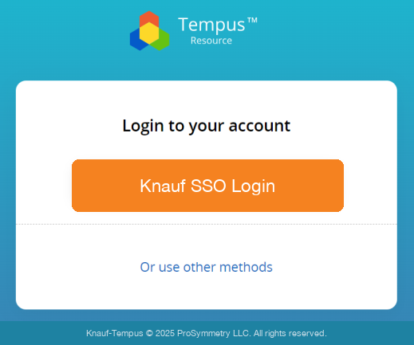
3.Sign in using your standard credentials.
HOMEPAGE
1.All PM users will have access to 3 tiles on the homepage. Click on any tile to navigate to the relevant page.
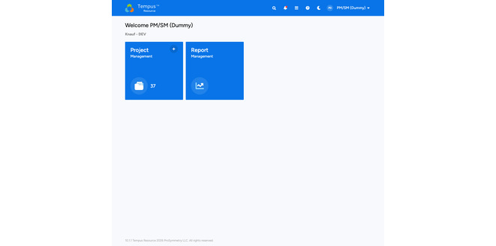
2.The below table provides a high-level description of actions users can perform behind each tile. Note: The actions may vary depending on each user’s role and access permissions.
Tile name | Description
Project Management | • View project repository  • View/Create/Edit assignments on individual projects  • View resource request status on individual projects
Bulk Project Allocation Flatgrid | • View/Create/Edit assignments on multiple projects  • View resource request status for multiple projects
SHS Privacy Notice | Detailed custom privacy statement for Knauf
Valkeen GmbH ∙ Bahnhofstrasse 64 ∙ 8001-Zürich, Switzerland
www.valkeen.com ∙ © 2025 Valkeen GmbH. All rights reserved.
CONFIDENTIALITY/EMAIL NOTICE: The material in this document contains confidential and privileged information intended only for the addressee. Do not distribute, copy, forward, or disclose the contents of this document without the express consent of Valkeen GmbH.
Page 5 of 20

User Guide 
3.The blue ribbon along the top (Task Bar) is available from all screens in Tempus.
• Click on the Tempus logo to the left to return to the homepage from any screen
• View notifications by clicking on the bell icon
• Locate a specific project via Global Search
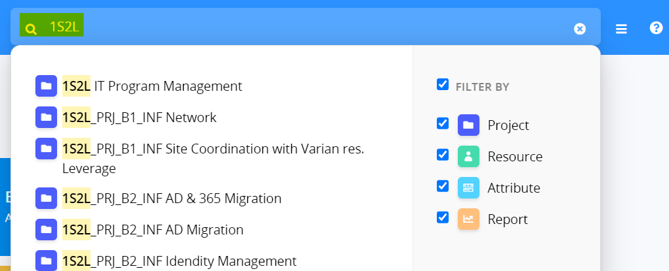
• Navigate to any area of the tool via the hamburger menu
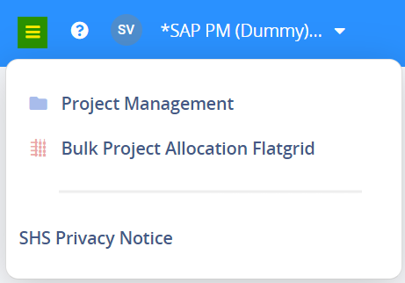
• From the username menu, set up in-app Subscriptions or Logout.
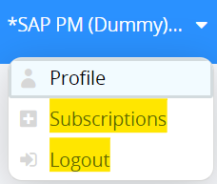
Valkeen GmbH ∙ Bahnhofstrasse 64 ∙ 8001-Zürich, Switzerland
www.valkeen.com ∙ © 2025 Valkeen GmbH. All rights reserved.
CONFIDENTIALITY/EMAIL NOTICE: The material in this document contains confidential and privileged information intended only for the addressee. Do not
distribute, copy, forward, or disclose the contents of this document without the express consent of Valkeen GmbH.
Page 6 of 20

User Guide | 

RECOMMENDED NOTIFICATION SUBSCRIPTIONS
There are 2 spaces with recommended notifications for Project Managers.
1.In the Project tab, Add projects to be notified for. Do not select all projects as each will need to be unsubscribed from manually.
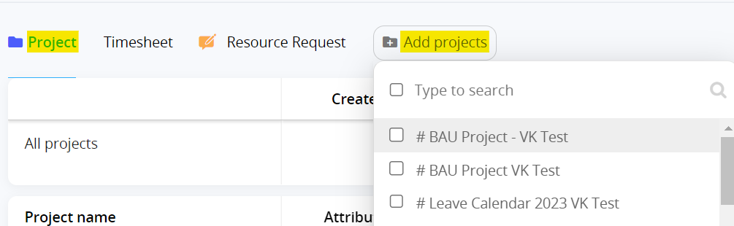
• Subscribe to be notified for 3 notifications highlighted below.
oAttributes will notify you of any updates to project attributes. oAllocations will notify you of any updates to project allocations. oDeleted will notify you of when a project is altogether deleted.
• To unsubscribe from a project, click 
2.In the Resource Request tab, choose to be notified for any specific (or all) outcomes of a resource request submitted by you.
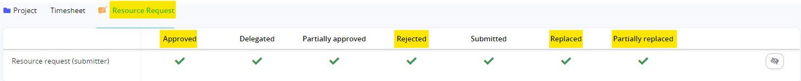
Valkeen GmbH ∙ Bahnhofstrasse 64 ∙ 8001-Zürich, Switzerland
www.valkeen.com ∙ © 2025 Valkeen GmbH. All rights reserved.
CONFIDENTIALITY/EMAIL NOTICE: The material in this document contains confidential and privileged information intended only for the addressee. Do not distribute, copy, forward, or disclose the contents of this document without the express consent of Valkeen GmbH.
Page 7 of 20

User Guide | 

PROJECT MANAGEMENT GRID
Click the Project Management tile to open the Project List, where you have access to the entire project repository.
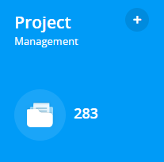
GRID OVERVIEW
1.There are various options to customise the Project management grid.
• Search for a project or projects by name via the search field, which uses “contains” logic.
• Filter projects by applying as many filters as needed.
• Add or remove Columns.
• Group projects based on any attribute(s). Each grouping level will display the group by attribute, attribute
value, and the count of projects contained in the grouping.
• Use Quick filters to navigate to relevant projects e.g., “my projects” will show projects where the logged in
user is assigned as the Project Owner
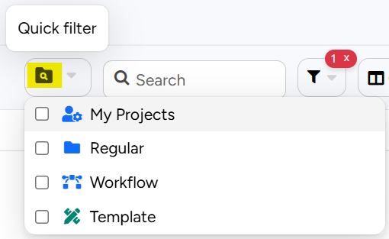
2.Open the View Management dialog by clicking on the view name to the right of the Group By option.
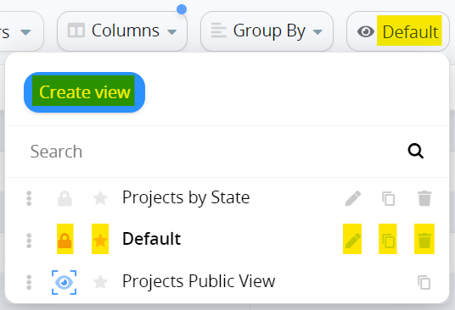
• Create a new view by clicking Create view
Valkeen GmbH ∙ Bahnhofstrasse 64 ∙ 8001-Zürich, Switzerland
www.valkeen.com ∙ © 2025 Valkeen GmbH. All rights reserved.
CONFIDENTIALITY/EMAIL NOTICE: The material in this document contains confidential and privileged information intended only for the addressee. Do not
distribute, copy, forward, or disclose the contents of this document without the express consent of Valkeen GmbH.
Page 8 of 20

User Guide |  | 
• | Lock a view in its current state by clicking
• | Select a Default view by clicking
• | Edit a view by clicking
• | Clone a view by clicking
• | Delete a view altogether by clicking
3.Public views are denoted by the blue eye shaped icon 
These views cannot be edited in any way as they are administratively defined.

Always clone a public view using the copy icon
into it.

, and then click into the newly created view to start working

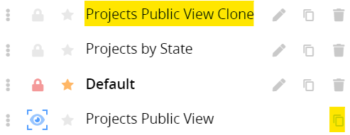
4.Project navigation using Advanced Tooltips
Hovering over any project name in the Project Management grid will reveal all areas of the project that the user has access to. Clicking on any area will navigate directly to the selected area of the project.

VIEWING PROJECT ATTRIBUTES
1.Clicking on any project name in the grid will navigate to the Individual project screen.
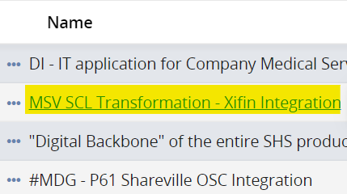
2.From the top-right corner of the screen, navigate to Attributes to view attributes.
Valkeen GmbH ∙ Bahnhofstrasse 64 ∙ 8001-Zürich, Switzerland
www.valkeen.com ∙ © 2025 Valkeen GmbH. All rights reserved.
CONFIDENTIALITY/EMAIL NOTICE: The material in this document contains confidential and privileged information intended only for the addressee. Do not distribute, copy, forward, or disclose the contents of this document without the express consent of Valkeen GmbH.
Page 9 of 20

User Guide | 
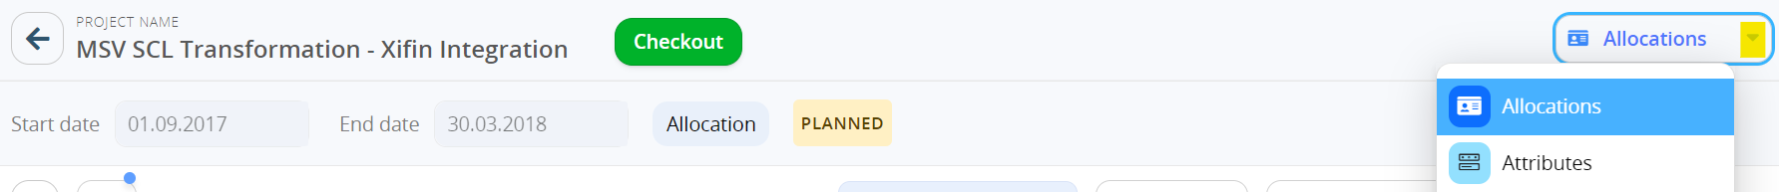

SINGLE PROJECT ALLOCATION GRID
1.Clicking on any project name in the grid will navigate to the Single Project Allocation grid by default.
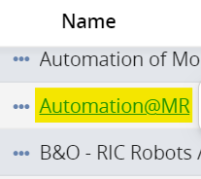
2.Once a project has been created, and a valid date range has been entered, the Single Project Allocation grid
will become available.

GRID OVERVIEW
1.The Project Name and Checkout button is located at the top of the grid.
To make any changes to a project, it must first be checked out.
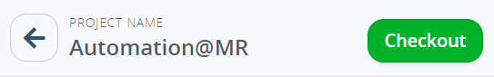
2.Basic options to update the grid are in the ribbon below the project start and end date.
• Expand the grid with one-click by clicking on 
• Search for an assigned resource when the grid is grouped by Resource and for a task name when the grid is
grouped by Task.
• Group by either Resource or Task.
• Insert Columns to view project, resource, or assignment attributes.
• Update Time Granularity by which allocations are displayed.
Month is the recommended granularity for Knauf.
Valkeen GmbH ∙ Bahnhofstrasse 64 ∙ 8001-Zürich, Switzerland
www.valkeen.com ∙ © 2025 Valkeen GmbH. All rights reserved.
CONFIDENTIALITY/EMAIL NOTICE: The material in this document contains confidential and privileged information intended only for the addressee. Do not
distribute, copy, forward, or disclose the contents of this document without the express consent of Valkeen GmbH.
Page 10 of 20

User Guide |  | 
• | Choose the Capacity unit in which allocations are entered/displayed.
Hours is the recommended unit for Knauf.
3.Advanced grid options can be found in the Options menu in the ribbon below the project timeframe.
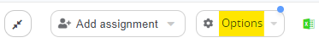
• Enabling the Total Column will display a column with total Hours or Mandays.
When viewing the grid in FTE or FTE%, it will display the average.
• A Resource Heatmap will display colours based on overall allocation% of a resource.
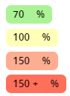
• A Resource Request Heatmap will display colours based on the resource request status.
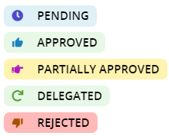
•  •  •  • | Enabling Overlay Heatmap for Rows will apply the selected heatmap on individual grid rows. Enabling Overlay Heatmap for Groups will apply the selected heatmap on groupings.  Tasks to Show will filter tasks and hide the task type that is not selected – generic or non-generic. The Date Range Filter will filter the grid for a specific timeframe without amending project timeframe.

CREATING RESOURCE REQUESTS
1.Click Checkout next to the Project Name at the top to make any edits to the project.
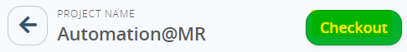
2.Expand the grid by clicking on  above the Name column in the grid.
3.To add a single resource, click on a blue cell reading Type a new resource to start typing the name of the
resource or select a resource from the dropdown.
Type-ahead functionality narrows down the available resources to simplify resource loading.
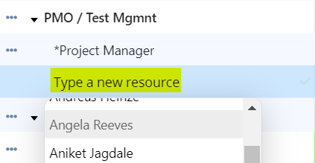
Valkeen GmbH ∙ Bahnhofstrasse 64 ∙ 8001-Zürich, Switzerland
www.valkeen.com ∙ © 2025 Valkeen GmbH. All rights reserved.
CONFIDENTIALITY/EMAIL NOTICE: The material in this document contains confidential and privileged information intended only for the addressee. Do not
distribute, copy, forward, or disclose the contents of this document without the express consent of Valkeen GmbH.
Page 11 of 20

User Guide 
4.To add multiple resources to one or multiple tasks, click on Add assignment to reveal the New Assignment dialog. Choose resources to the left and tasks to the right and click Add.
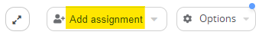
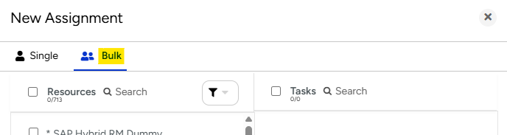
5.To create a new task, scroll down to the end of the Task list to reveal a green row with the option to Type a new Task. Enter the name of the new task and hit enter or click the checkmark to the right of the cell.
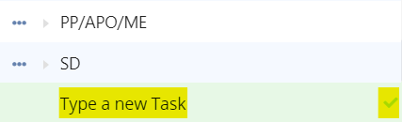
6.Enter any relevant assignment attributes like Module, Role, Skills, Additional comments.
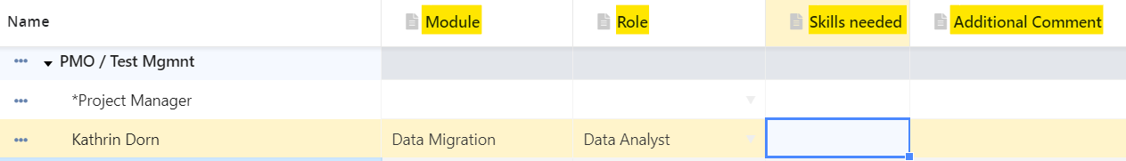
7.Enter the allocation in Hours on a monthly level. Values can be copy-pasted or clicked and dragged.
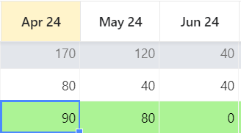
8.To request additional capacity from a named resource that has already been allocated to a project, enter the new total requested allocation directly in the grid.
9.To save changes, click Save and Check In or Release them to revert to the previous state.
Valkeen GmbH ∙ Bahnhofstrasse 64 ∙ 8001-Zürich, Switzerland
www.valkeen.com ∙ © 2025 Valkeen GmbH. All rights reserved.
CONFIDENTIALITY/EMAIL NOTICE: The material in this document contains confidential and privileged information intended only for the addressee. Do not distribute, copy, forward, or disclose the contents of this document without the express consent of Valkeen GmbH.
Page 12 of 20

User Guide | 

ADVANCED ASSIGNMENT OPTIONS
When allocation is assigned to a resource, select “Assignment Options” from the ellipses next to the resource’s name to Clone or Shift the assignment.
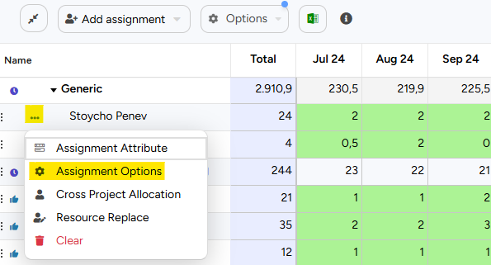
•To clone an assignment, click on Clone or move the assignment to a new start date. Alternatively, move the assignment to a different task, a new task altogether, or to a different resource.
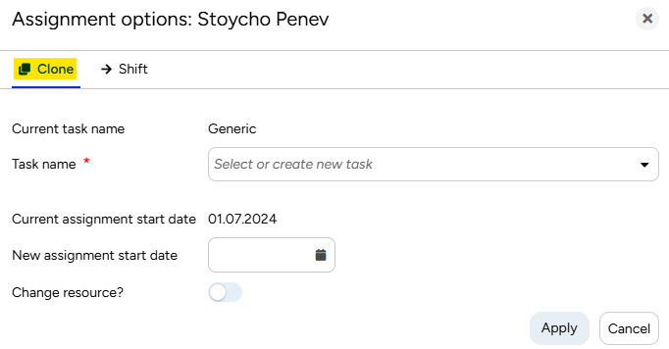
•To shift an assignment, click on Shift and enter a new assignment start date.
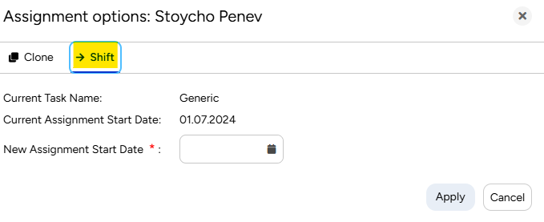
Valkeen GmbH ∙ Bahnhofstrasse 64 ∙ 8001-Zürich, Switzerland
www.valkeen.com ∙ © 2025 Valkeen GmbH. All rights reserved.
CONFIDENTIALITY/EMAIL NOTICE: The material in this document contains confidential and privileged information intended only for the addressee. Do not distribute, copy, forward, or disclose the contents of this document without the express consent of Valkeen GmbH.
Page 13 of 20

User Guide | 

VIEWING RESOURCE REQUEST STATUS
Resource request status can be viewed from the Single Project Allocation grid at any time. The resource request status
will be denoted by an icon to the left of a resource name:
•  •  • | Pending requests are denoted by   Approved requests are denoted by
 | Rejected requests are denoted by
Valkeen GmbH ∙ Bahnhofstrasse 64 ∙ 8001-Zürich, Switzerland
www.valkeen.com ∙ © 2025 Valkeen GmbH. All rights reserved.
CONFIDENTIALITY/EMAIL NOTICE: The material in this document contains confidential and privileged information intended only for the addressee. Do not
distribute, copy, forward, or disclose the contents of this document without the express consent of Valkeen GmbH.
Page 14 of 20

User Guide | 

BULK PROJECT ALLOCATION FLATGRID
The Bulk Project Allocation Flatgrid (BPA Flatgrid) is particularly useful for project managers owning multiple projects
at the same time. To access the BPA Flatgrid, click on the Bulk Project Allocation Flatgrid tile.
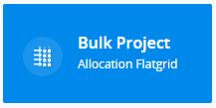
GRID OVERVIEW
1.Located at the top-left, is the Project timeframe, which can be easily amended by the date-picker.

Additionally, there is a quick-select menu revealed by clicking 
to choose from.

next to the End date with popular timeframes

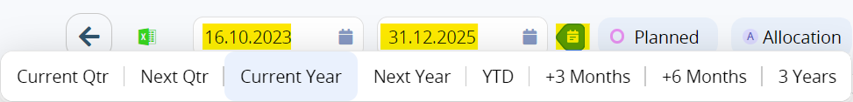
2.Towards the top-centre, is the Resource and Project menu, with 3 modes for entering data –
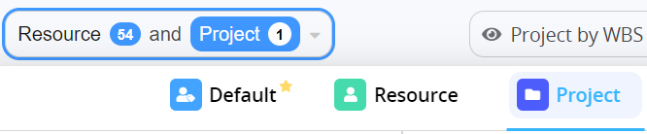
• Project – Recommended mode for Project Managers.
Only projects can be selected. Only projects that coincide with the grid timeframe and with planned
allocations will appear in the list.
• Resource – Recommended mode for Resource Managers.
Only resources can be selected. Only resources with planned allocation during the grid timeframe will
appear in the list.
• Default – Recommended when updating allocations or adding assignments to resources not already
assigned to a project.
All projects and resources that the user has access to can be selected.
3.To the top-right, is the View Management dialog.
• Create a new view by clicking Create view
• Lock a view in its current state by clicking
• Select a Default view by clicking
• Edit a view by clicking
• Clone a view by clicking
Valkeen GmbH ∙ Bahnhofstrasse 64 ∙ 8001-Zürich, Switzerland
www.valkeen.com ∙ © 2025 Valkeen GmbH. All rights reserved.
CONFIDENTIALITY/EMAIL NOTICE: The material in this document contains confidential and privileged information intended only for the addressee. Do not
distribute, copy, forward, or disclose the contents of this document without the express consent of Valkeen GmbH.
Page 15 of 20

User Guide
•Delete a view altogether by clicking
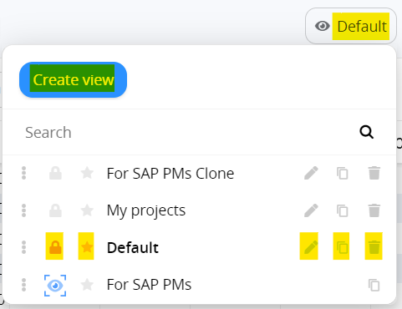



4.Basic options for customisation are in the ribbon above the grid.
• Expand the grid with one-click by clicking on 
• Insert Columns to view project, resource, or assignment attributes in the grid.
• Group by any project, resource, or assignment attribute.
• Update Time Granularity by which allocations are displayed.
Month is the recommended granularity for Knauf.
• Choose the Capacity unit in which allocations are entered/displayed.
Hours is the recommended unit for Knauf.
5.Advanced options for customisation are in the Options menu in the ribbon above the grid.
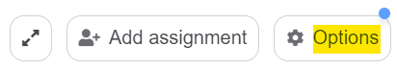
• Overlay Heatmap
oResource Heatmap will display colours based on overall allocation% of a resource.

oResource Request Heatmap will display colours based on the resource request status.

oNon-Zero Heatmap will display non-zero cells in blue
• Hide Task will hide the task column in cases where it is not relevant
• Show Total Row will insert a row with total allocations at every aggregation level.
• Show Total Demand Planning will display total allocations on Demand Planning or Generic Resources.
• Show Named Total will display total allocations on all Named Resources.
Valkeen GmbH ∙ Bahnhofstrasse 64 ∙ 8001-Zürich, Switzerland
www.valkeen.com ∙ © 2025 Valkeen GmbH. All rights reserved.
CONFIDENTIALITY/EMAIL NOTICE: The material in this document contains confidential and privileged information intended only for the addressee. Do not
distribute, copy, forward, or disclose the contents of this document without the express consent of Valkeen GmbH.
Page 16 of 20

User Guide 
• Show Unallocated% will display the percentage of assignments to be redistributed from Generic Resources to Named Resources.
• Show Selection Calculations will display Average, Sum, Min, Max, Count for a grid selection • TaskstoShow can filter the grid by task type – Generic (Project-level) or Non-Generic (Custom tasks) • Weekly Display Format will display weeks in the chosen format – Week number, Start date, End date • Filter by Resource Request Status allows to filter the grid by a specific status.
6.Every column has a filter icon that allows to filter across resources, projects, and other inserted columns
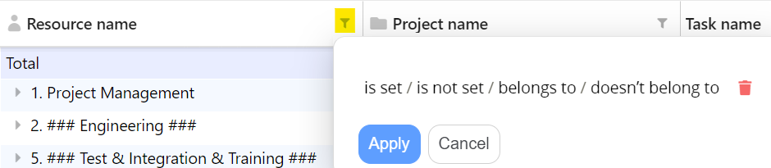
7.A blue triangle in cells containing project and resource names opens a view only modal window for all project/resource attributes
8.Hovering over a Project or Resource name reveals a hyperlink.
Clicking on the link will redirect to the dedicated Project or Resource page in a new browser tab
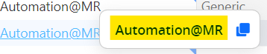
CREATING VIEWS USING A PUBLIC VIEW
There is 1 public view available to Project Managers to use as a reference point for creating their own views called For SAP PMs.
1.From the View management dropdown, clone the For SAP PMs view and click into the newly cloned view.
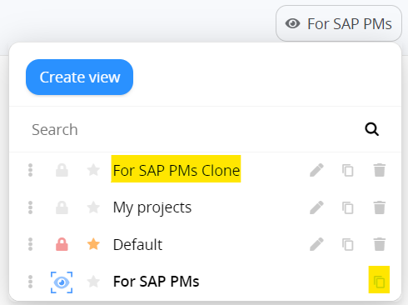
2.Ensure that the correct timeframe has been selected.
Open the Resource and Project menu by clicking on it.
Valkeen GmbH ∙ Bahnhofstrasse 64 ∙ 8001-Zürich, Switzerland
www.valkeen.com ∙ © 2025 Valkeen GmbH. All rights reserved.
CONFIDENTIALITY/EMAIL NOTICE: The material in this document contains confidential and privileged information intended only for the addressee. Do not distribute, copy, forward, or disclose the contents of this document without the express consent of Valkeen GmbH.
Page 17 of 20

User Guide 
3.Locate project(s) by typing in the name in the search field next to Projects or apply a project filter to see multiple projects meeting the same criteria.
Only projects with planned allocations during the timeframe selected will appear in the Projects list. Select projects from the list. Assigned resources will be auto selected to the left.
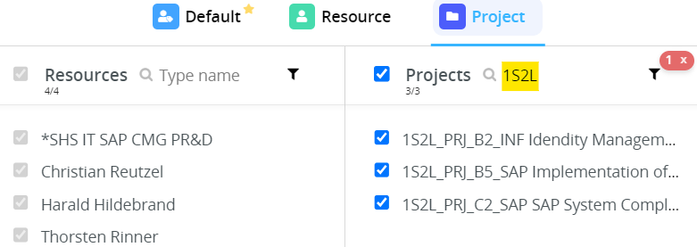
4.The BPA Flatgrid will display a dedicated row for each Resource-Project-Task combination. Existing allocations will appear in Hours on a monthly level with a Resource heatmap applied.
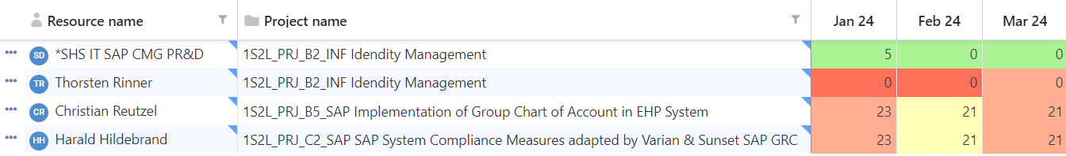
ACTIONS IN THE BPA FLATGRID
Project Managers can perform 3 actions in the BPA Flatgrid. Each of these actions is outlined below.
UPDATE EXISTING ASSIGNMENTS
1.The BPA Flatgrid will display a dedicated row for each Resource-Project-Task combination. To update an assignment, click into a cell and update the value.
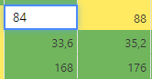
2.Click Save at the top of the grid to save changes and trigger a new resource request.
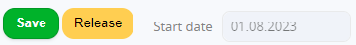
Valkeen GmbH ∙ Bahnhofstrasse 64 ∙ 8001-Zürich, Switzerland
www.valkeen.com ∙ © 2025 Valkeen GmbH. All rights reserved.
CONFIDENTIALITY/EMAIL NOTICE: The material in this document contains confidential and privileged information intended only for the addressee. Do not distribute, copy, forward, or disclose the contents of this document without the express consent of Valkeen GmbH.
Page 18 of 20

User Guide | 
ADD NEW ASSIGNMENTS
1.Click on Add assignment.
Select a Project, a Resource, and a Task and click Add new assignment.
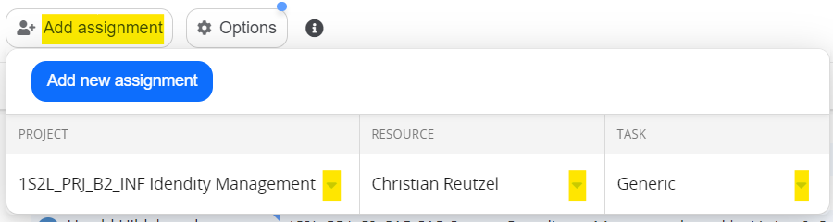
2.To select a resource not already assigned to a project, select the checkbox Allow new Resources from the Resource dropdown.
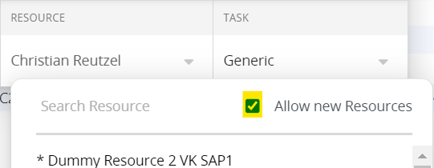
3.To create a new task not already present in the project, enter the name of the task and click Add new Task
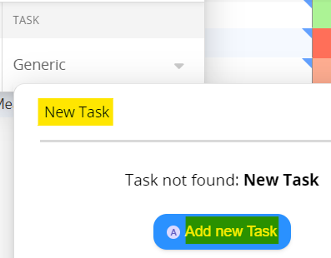
4.A new row with the Project-Resource-Task combination will appear in the grid. To add assignments, click on a cell and enter the assignment value.
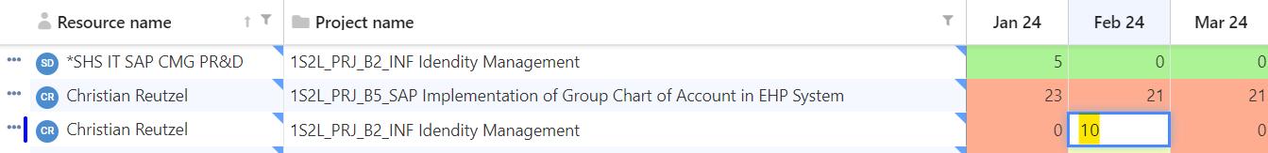
5.Click Save at the top of the grid to save changes and trigger a new resource request.
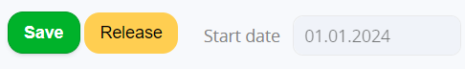
Valkeen GmbH ∙ Bahnhofstrasse 64 ∙ 8001-Zürich, Switzerland
www.valkeen.com ∙ © 2025 Valkeen GmbH. All rights reserved.
CONFIDENTIALITY/EMAIL NOTICE: The material in this document contains confidential and privileged information intended only for the addressee. Do not distribute, copy, forward, or disclose the contents of this document without the express consent of Valkeen GmbH.
Page 19 of 20

User Guide | 
VIEW PENDING RESOURCE REQUESTS
1.From the bottom of the Options menu, select the dropdown next to Filter by Resource Request Status
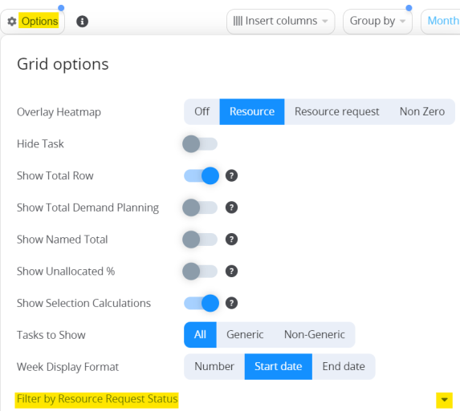
2.Select the checkbox next to Pending. The grid will automatically be filtered to only show pending requests.
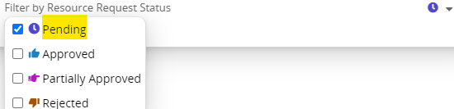
Valkeen GmbH ∙ Bahnhofstrasse 64 ∙ 8001-Zürich, Switzerland
www.valkeen.com ∙ © 2025 Valkeen GmbH. All rights reserved.
CONFIDENTIALITY/EMAIL NOTICE: The material in this document contains confidential and privileged information intended only for the addressee. Do not distribute, copy, forward, or disclose the contents of this document without the express consent of Valkeen GmbH.
Page 20 of 20

